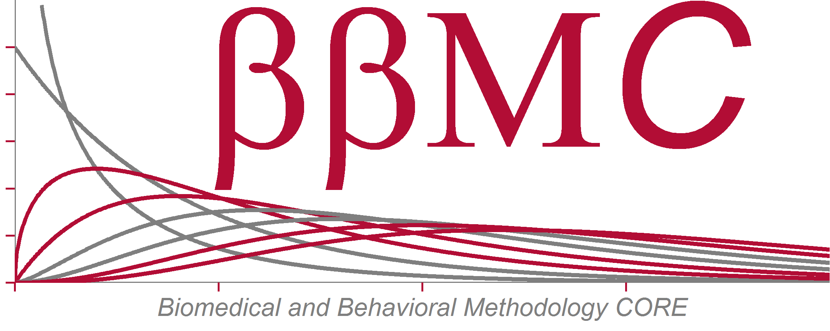

**Appendix B: Data Use Agreement – for Use of REDCap and REDCap Survey**

THE UNIVERSITY OF OKLAHOMA HEALTH SCIENCES CENTER RESEARCH DATA USE AGREEMENT - REDCap

I have received and reviewed the University of Oklahoma Health Sciences Center (OUHSC) Policy “Appropriate Use of REDCap and REDCap Survey” and agree to abide by its provisions. This Data Use Agreement is subject to the requirements of the Federal Health Insurance Portability and Accountability Act of 1996 and its implementing regulations (“HIPAA”), and I agree to comply with the requirements of HIPAA applicable to the activities contemplated by this Agreement.

I understand that violating the provisions of the Policy constitutes grounds for disciplinary actions as determined by applicable privacy laws and OUHSC policies and procedures.

1 Print User’s Name:

2 User’s Signature

3 User’s OUHSC title:

4 User’s OUHSC Department:

5 User’s Email address:

6 Protocol title:

7 IRB number, if applicable:

8 IRB approval dates (from – to), if applicable:

9 Date

Page 1 of 1

Data Use Agreement REDCap x/xx/2013